*Nonparametric Tests: Independent Samples.

NPTESTS

/INDEPENDENT TEST (surprise calm happiness sadness disgust anger fear) GROUP (isAppleEmployee)

/MISSING SCOPE=ANALYSIS USERMISSING=EXCLUDE

/CRITERIA ALPHA=0.05 CILEVEL=95.

**Nonparametric Tests**

|  |  |  |
| --- | --- | --- |
| **Notes** | | |
| Output Created | | 12-MAY-2020 20:46:50 |
| Comments | |  |
| Input | Data | C:\Users\Leslie\Insync\leslieklieb@gmail.com\Google Drive\Webster teaching (2)\student supervisions\Nic\comments may 9\data nic 2.sav |
| Active Dataset | DataSet1 |
| Filter | <none> |
| Weight | <none> |
| Split File | <none> |
| N of Rows in Working Data File | 1784 |
| Syntax | | NPTESTS  /INDEPENDENT TEST (surprise calm happiness sadness disgust anger fear) GROUP (isAppleEmployee)  /MISSING SCOPE=ANALYSIS USERMISSING=EXCLUDE  /CRITERIA ALPHA=0.05 CILEVEL=95. |
| Resources | Processor Time | 00:00:00.75 |
| Elapsed Time | 00:00:00.69 |

**null : null**

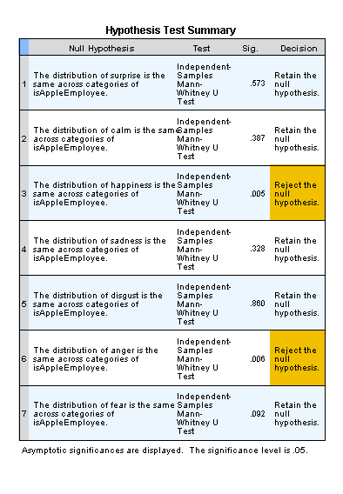

*Nonparametric Tests: Independent Samples.

NPTESTS

/INDEPENDENT TEST (surprise calm happiness sadness disgust anger fear) GROUP (Category) KRUSKAL_WALLIS(COMPARE=PAIRWISE) MEDIAN(TESTVALUE=SAMPLE COMPARE=PAIRWISE)

/MISSING SCOPE=ANALYSIS USERMISSING=EXCLUDE

/CRITERIA ALPHA=0.05 CILEVEL=95.

**Nonparametric Tests**

|  |  |  |
| --- | --- | --- |
| **Notes** | | |
| Output Created | | 12-MAY-2020 21:05:44 |
| Comments | |  |
| Input | Data | C:\Users\Leslie\Insync\leslieklieb@gmail.com\Google Drive\Webster teaching (2)\student supervisions\Nic\comments may 9\data nic 2.sav |
| Active Dataset | DataSet1 |
| Filter | <none> |
| Weight | <none> |
| Split File | <none> |
| N of Rows in Working Data File | 1784 |
| Syntax | | NPTESTS  /INDEPENDENT TEST (surprise calm happiness sadness disgust anger fear) GROUP (Category) KRUSKAL_WALLIS(COMPARE=PAIRWISE) MEDIAN(TESTVALUE=SAMPLE COMPARE=PAIRWISE)  /MISSING SCOPE=ANALYSIS USERMISSING=EXCLUDE  /CRITERIA ALPHA=0.05 CILEVEL=95. |
| Resources | Processor Time | 00:00:00.52 |
| Elapsed Time | 00:00:00.24 |

**null : null**

